**Stay active**

**but stay apart**

**2 m**

**(6 ft)**

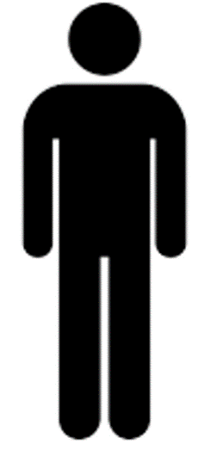

**Avoid**

**crowds**

**Maintain a two meter**

**distance from others**