**Detour Notice for Route 72**



**Effective Tuesday August 5, 2025, to Wednesday 13, 2025**

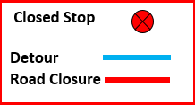**Millstone Ave will be closed from Hunter Street to Townsite Road. Please use alternate bus stops located by Cadogan Street.**

**Millstone Avenue**

**Townsite Road**

**Sunderland Avenue**

**Hunter Street**

|  |  |
| --- | --- |
| **For more information, please contact:** | |
|  | Transportation Services |
|  | Regional District of Nanaimo |
|  | 250-390-4111 |
|  | transit@rdn.bc.ca |