**Detour Notice for Route 72**



**Effective Monday July 28, 2025 to Wednesday July 30, 2025**

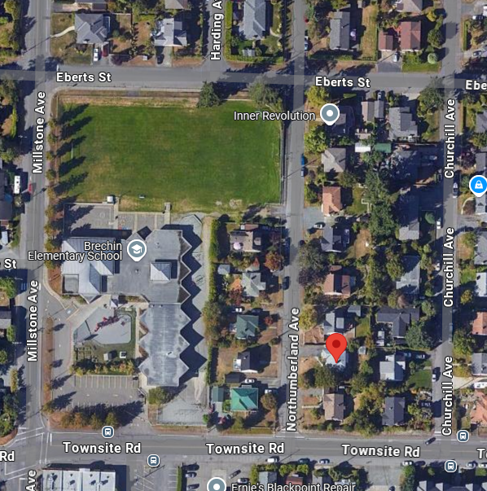**Millstone Ave will be closed from Eberts Street to Townsite Road. Please use alternate bus stops located on Townsite Road.**

**Townsite Road**

**Eberts Street**

**Northumberland Ave**

**Closed Stops**

**Alternate Stops**

**Road Closed**

**Detour**

|  |  |
| --- | --- |
| **For more information, please contact:** | |
|  | Transportation Services |
|  | Regional District of Nanaimo |
|  | 250-390-4111 |
|  | transit@rdn.bc.ca |