**Due to road work at the intersection of Bowen Road at Northfield Road, route 25 will detour via Bowen Road to Meredith Road to Spencer Road to Northfield Road on both directions .**

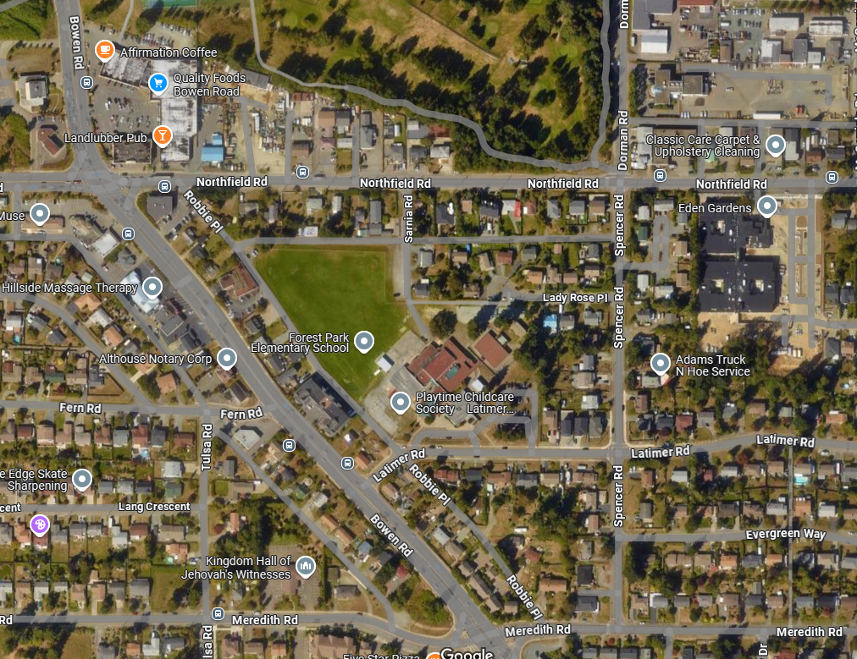

Spencer Road

Meredith Road

Bowen Road

Northfield Road

**Detour Route:**

**Road Closure:**

**Bus Stop Closures:**

**Available Stops:**

|  |  |
| --- | --- |
| **For more information, please contact:** | |
|  | Transportation Services |
|  | Regional District of Nanaimo |
|  | 250-390-4111 |
|  | transit@rdn.bc.ca |