
Detour Notice for Route 40

Effective Tuesday December 9, 2025, from 7AM to 5PM
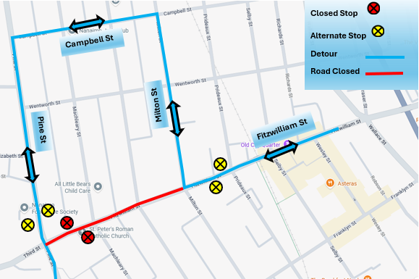
Fitzwilliam Street will be closed starting from Milton Street to Pine Street. Please use alternative bus stops in the area.
For more information, please contact:
 | Transportation Services
 | Regional District of Nanaimo
 | 250-390-4111
 | transit@rdn.bc.ca

