 |   Service Alert  Bus Stop Closure

Due to contruction this bus stop will be closed effective Monday October 20, 2025 until further notice.
Please use temporary stops on Drew Road and Lee Road for traveling North.
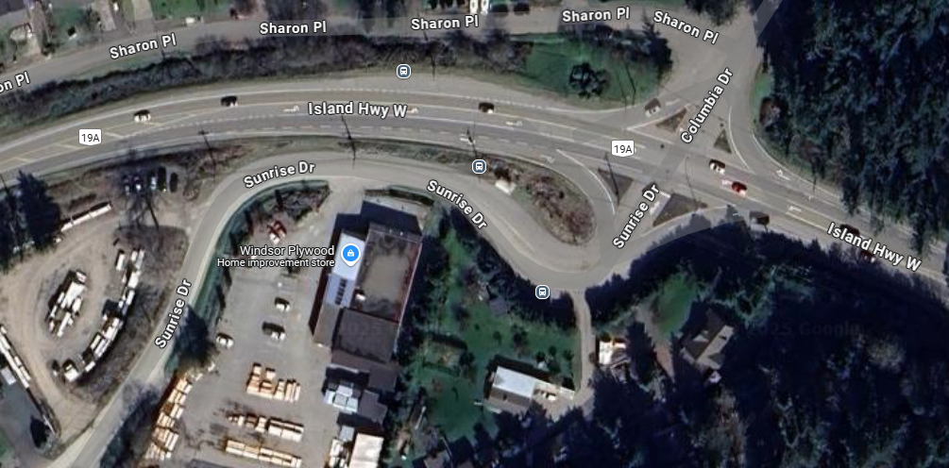

For more information, please contact:
 | Transportation Services
 | Regional District of Nanaimo
 | 250-390-4111
 | transit@rdn.bc.ca

