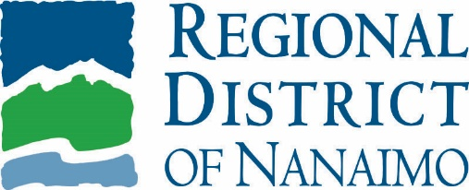 |   Service Alert
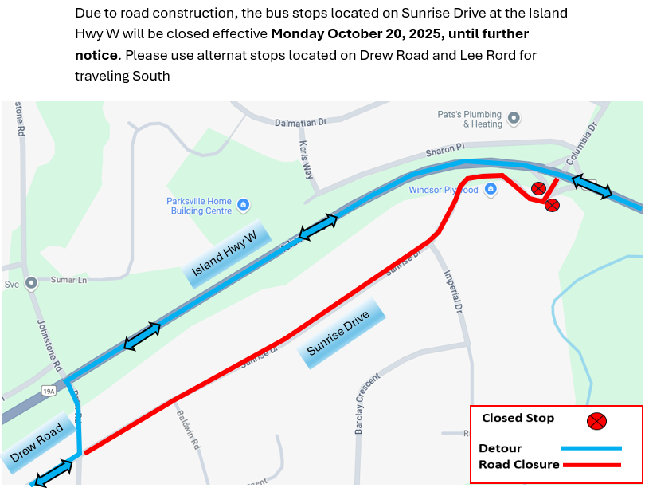

For more information, please contact:
 | Transportation Services
 | Regional District of Nanaimo
 | 250-390-4111
 | transit@rdn.bc.ca

