|  |  |
| --- | --- |
|  | *service alert* **April 21 to April 23, 2025** |

Due to road work on Bowen Road, **Route 40** to Downtown will detour via Boxwood Road. Please use alternate stops on Bowen Road and Meredith Road as well as the temporary stop on Boxwood Road.

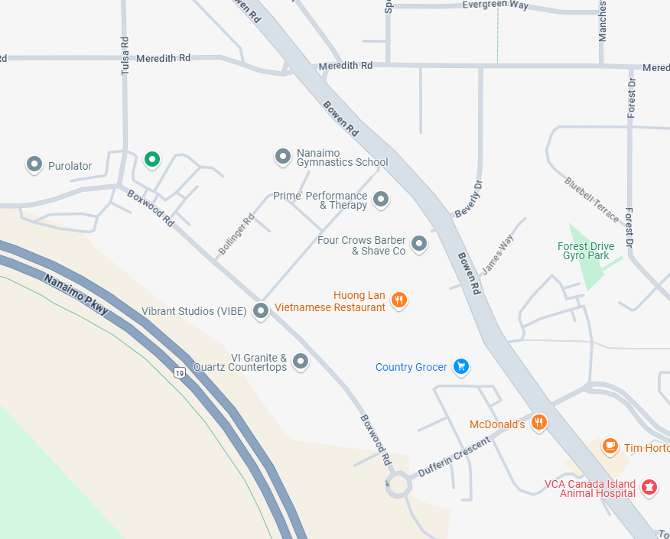

Detour:

Closed Stop: 

Available Stop: 

Temporary Stop: 

**Meredith Road**

**Dufferin Crescent**

**Boxwood Road**

|  |  |
| --- | --- |
| **For more information, please contact:** | |
|  | Transportation Services |
|  | Regional District of Nanaimo |
|  | 250-390-4111 |
|  | transit@rdn.bc.ca |