Bees Wax Wraps and T.Shirt Bags
Lesson 7

Purpose: To teach students how to make alternatives to single use plastic (wrap and bags).

Materials:
*Fabric
*Parchment Paper
*3-4 Cookie Sheets (Bought at Value Village) per class
*3-4 Irons (Bought at Value Village) per class
*pine resin (Purchased on Amazon)
*bees wax (Purchased on Amazon)
*coconut oil
*used T.Shirts (students bring them from home, but I provided some as well)
*Pinking shears
*Fabric scissors (if available or regular ones will do)

Note: Thanks to the generous support of the RDN, we were able to purchase these items with our RDN grant.

Procedure (give yourself 1 1/2-2 hours for this lesson):
1. Divide students into two groups. One group will be making the bees wax wraps while the other makes the T.Shirt bags. Then swap.
Bees Wax Wraps:
- Students use a template to draw a square on the fabric they have chosen – they should use the corner/edge to conserve fabric
- They cut out their fabric using the pinking shears
- Place fabric square on a cookie sheet covered in parchment
- They sprinkle wax, resin and coconut oil on fabric (see exact measurements below) and cover with another sheet of parchment paper
- Iron fabric trying to ensure wax covers the whole square of fabric. Students need to press down hard on the iron and ensure all wax is melted and pushed to the edges of their fabric
- Students remove the parchment paper and peel off the fabric as soon as they have finished ironing
- They should wave the fabric gently to allow the wax to dry
T.Shirt Bag:
- Each student chooses a T.Shirt or uses the one they brought
- They cut off the sleeves and then cut strips into the bottom of the T.shirt towards the top to create a fringe (3-4 inches long)
- They tie the strips together
2. Once students have completed one task, they move onto the next one.

Note: Booking a larger space, if available, is helpful.
If a parent or older student can volunteer, it helps to have the extra support.

Bees Wax Wrap Recipe

Just over 1 Tbsp of wax
Just under 1 tsp of pine resin
1/8 tsp of coconut oil
100% cotton fabric
Pinking shears
Iron
Parchment Paper

T.Shirt Bag Picture

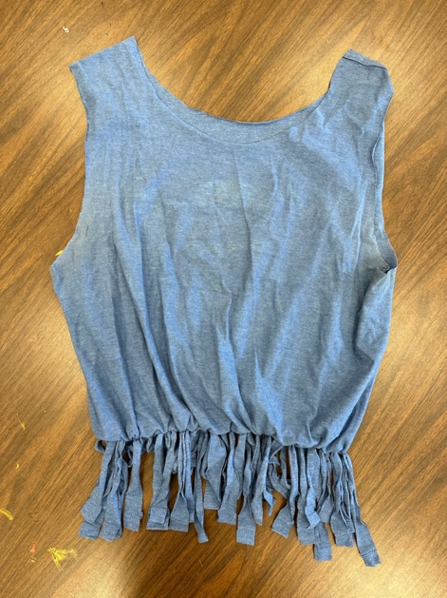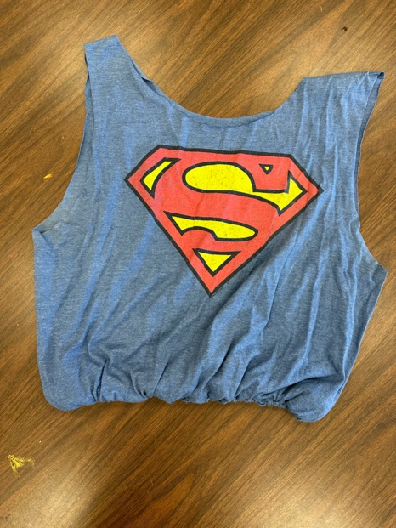
You can flip the T-shirt so the fringe is on the inside.

