Hydroponics

Lesson 6

**Purpose:** To show students alternative forms of gardening that require less space and less water.

To show students how easy it is to grow their own food and thus reduce waste.

**Materials:**

*Apple sauce containers for each child (do not use dollar store brands as the lip is too small for this activity)

*Small mouth, glass mason jars

*Popsicle sticks

*Herb Seeds (lemon grass, basil, chives worked for us)

*Bag of dirt

*Powerpoint of Hydroponic and Aquaponic gardening

**Procedure (Give yourself 1 1/2-2 hours):**

1. Go through powerpoint. The following will be discussed during the powerpoint:

*Problems with food production. It is tricky because so much land is being used to raise cattle or for building. Population is growing and we have to feed them. Hydroponics can use previously unutilized space like roof tops.

*Talk about what we need to grow plants: water, sunlight, food (often from soil). So, if we have less soil to grow plants, what could we do to solve the problem?

*Talk about hydroponics. Anyone know what it means? Hydro from Greek word for water and ponics from work. Where might food come from in hydroponic gardening?

*Talk about where the food for plants can come from. Fertilizer. Discuss possible problems with fertilizer. Or, naturally from fish which introduces aquaponics.

*Discuss how hydroponic or aquaponic gardening could be used for space travel.

**Extensions:**

A. Show cabbage leaves sucking up water-discuss how plants take in water.

B. Set up several stations where plants can regrow themselves. Cut off and eat the stalks of celery, the root of carrots, the leaves of bok choy, the stems of green onions. Put the leftover part of the vegetables in a bowl of water (see picture below) and watch them regrow. Regrowing vegetables can provide additional food.

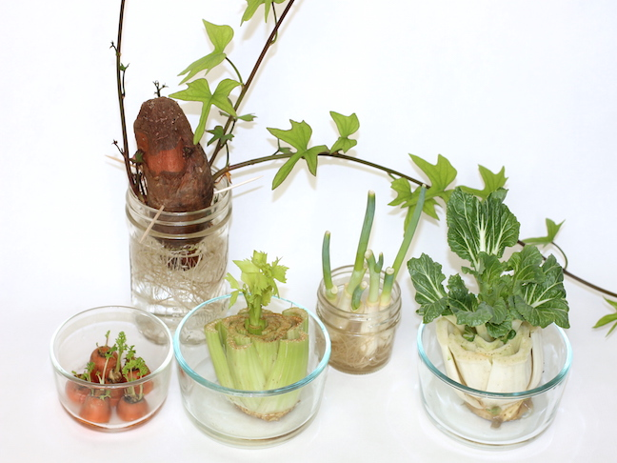

Some ideas of vegetables that regrow.

2. Give each student an apple sauce container (they will get to eat the applesauce) and a popsicle stick. Once students have eaten the apple sauce, they poke/cut a hole in the bottom of the plastic container and slide the popsicle stick through so that it mostly hangs out the bottom of the container. They then fill the container with dirt.

3. Students choose an herb to plant. They should plant several seeds. Follow package directions.

4. Once students have planted their seeds, they get a mason jar and fill it with water. They place their apple sauce container in the mouth of the jar. The lip of the container should prevent it from falling into the jar. The water should initially touch the bottom of the container because seeds like a moist environment. Eventually, the popsicle stick will draw the water up into the dirt.

5. Place plants in the sun.

**Note:** We used the herbs we grew in our cooking program to season food and make tea.

**Taking Care of Plants:**

1. When the seeds sprout, pinch off weaker looking shoots so that there is only one strong one per pot.

2. Students will need to add nutrients. This could be a science experiment with students adding different solutions (compost liquid, tea or coffee, store bought fertilizer, liquid manure, etc.)

**Note:** I have floated plants in a large tub with goldfish in the water to provide fertilization.

**Extension:**

Steam Challenge

Have students build something that floats but will also take a lot of weight for hydroponic gardening. You can make the project more challenging by not letting students use styrofoam or plastic as floating beds since they would add a lot of waste to the environment. Have them think of a green solution.

**Possible materials to provide:**

Popsicle sticks Balsam wood

Corks Bamboo