 | Parks & Trails alert  September 28, 2026

Construction Notice – Maple Lane Community Park – Field
To improve the condition of the field, field levelling and grass seeding will take place from October 5 to October 9. During this work, the park will be fully closed to the public to ensure public safety.

Once seeding is complete, the field area only will remain closed until November 16, or until the new turf has become sufficiently established. Keeping foot traffic off the field during this period is essential to the success of the restoration work and will help establish healthy, durable grass for future use.

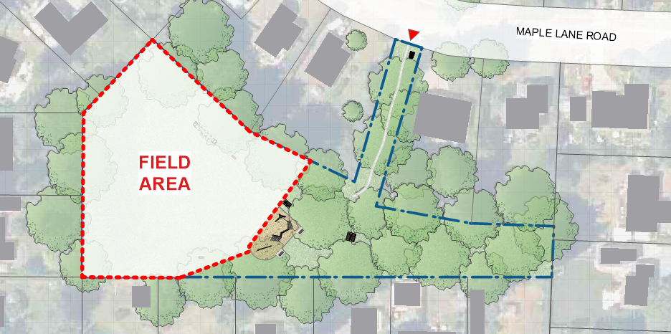
For more information, please contact:
 | Parks Services
 | Regional District of Nanaimo
 | 1-888-828-2069
 | rdnparks@rdn.bc.ca

