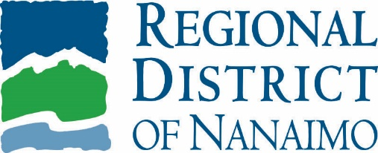 | SERVICES alert  February 23, 2023

Winter Weather Impacts on RDN Programs and Services

Due to winter conditions in the region, some Regional District of Nanaimo (RDN) programs and services have been impacted or may be impacted while the winter conditions continue. Visit the following RDN webpages and subscribe to service alerts for the most up-to-date information.

Transit
- Some transit routes may be delayed or detoured due to road conditions.
- Changes to routes can happen many times over the course of an adverse weather event and every effort is made to update transit users as information comes available.
- Visit rdn.bc.ca/transit-service-alerts for transit service updates.
- Follow Transit on Twitter: @RDN_Transit

Curbside Collection
- Today’s curbside collection routes will be impacted due to road conditions.
- During winter weather, every effort is made to collect the curbside materials. Residents should ensure their carts are at the curb for the entire 8 a.m. to 6 p.m. collection window.
- Check your collection route and sign up for the curbside app at rdn.bc.ca/curbside-collection to receive notifications by email, phone call or smartphone notification.

Recreation
- Recreation program participants will be contacted directly regarding any program cancellations.
- Visit rdn.bc.ca/recreation for information on any facility closures.
- Call 250-248-3252 or 250-752-5014 for more information.

Parks
- It is recommended to take caution and not enter forested parks and trails during adverse weather events.
- Some parking lots may be closed due to access constraints.
- Report any safety concerns within RDN parks and trails online at rdn.bc.ca/parks-safety-concern-form.

Service Alerts
- Keep up to date on all RDN services by subscribing to service alerts for transit, curbside collection, water and sewer, parks and more at rdn.bc.ca/service-alerts.

Emergency Preparedness
- Get better prepared for extreme weather and emergencies using the resources at rdn.bc.ca/emergency-preparedness and sign up for emergency alerts at rdn.bc.ca/voyent-alert.

Reporting Road Conditions
- Within RDN electoral areas, all roads and maintenance are the responsibility of the Ministry of Transportation Infrastructure and contracted to Mainroad Mid-Island Contracting LP. Please report changing road conditions to Mainroad's 24-hour hotline at 1-877-215-6006 and direct inquiries to midisland@mainroad.ca.
- The City of Nanaimo, City of Parksville, District of Lantzville and Town of Qualicum Beach are responsible for roads within their municipal boundaries including snow removal.

External Resources
- Check the latest weather warnings at weather.gc.ca/warnings/index_e.html.
- For the latest road conditions, advisories and tips, visit drivebc.ca or follow @DriveBC or @DriveBC_VI on Twitter.

- 30 -

For more information, please contact:
Rebecca Taylor
Communications Coordinator
Regional District of Nanaimo
250-390-6502
rtaylor@rdn.bc.ca

