RECOMMENDATION
That the Year-In-Review Update - Drinking Water and Watershed Protection Program report be received for information.
.
- .

BACKGROUND

The Regional District of Nanaimo’s Drinking Water and Watershed Protection (DWWP) program action areas are organized into four related themes: Water Awareness and Stewardship; Water Information and Science; Water-Centric Planning and Policy Support; and Water Collaboration.
Highlights of the program accomplishments in 2020 under each theme are presented in Attachment 1, along with the associated progress indicators (for the full list of indicators please reference the DWWP Action Plan 2020-2030 Section 7.1, excerpted in the table below). The Attachment also includes a brief summary of program adaptations that were made related to COVID-19.
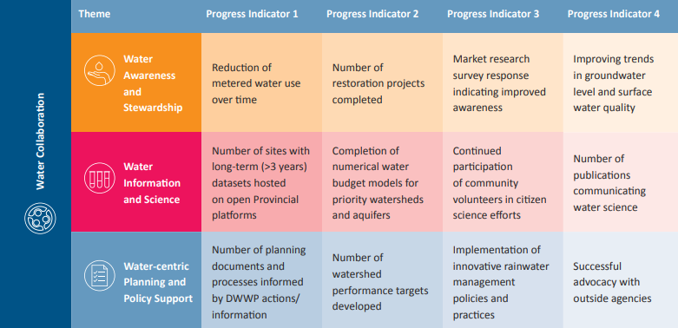

In 2021, the RDN DWWP program will continue to deliver key region-wide initiatives related to water stewardship, monitoring and planning – as detailed in the DWWP Action Plan, RDN Financial Plan, and RDN Operational Plan – and will report on progress four times a year via the DWWP Technical Advisory Committee as well as periodic report(s) to the Board. Highlighted workplan items in 2021 include:
- Develop an educational video series.
- Deliver a public benchmark survey.
- Complete and implement a redesign of outreach programs based on behaviour change principles.
- Update school programming for freshwater stewardship with curriculum connected modules and inquiry units, in partnership with education consultant and Nanaimo Area Land Trust.
- Increase rebate program funding and stewardship seed funding.
- Initiate the development of a regional rainwater management strategy.
- Continue water monitoring across the region.
- Advance groundwater data management and visualization tools.
- Complete a pilot project on watershed performance targets.
- Initiate work on the Phase 3 water budget study for the French Creek Water Region.
FINANCIAL IMPLICATIONS

N/A

STRATEGIC PLAN ALIGNMENT

This year-in-review informs the Board of progress against the recently updated Drinking Water and Watershed Protection Program Action Plan, a strategic priority under goal 2.0 Environmental Stewardship in the RDN Strategic Plan.

ATTACHMENT

- 2020 DWWP Program Accomplishments - Highlights by Theme

https://rdn.bc.ca/dwwp-action-plan

